## Project Documentation - Final Year Project Report Document

#### Middlesex University – London

#### Department of Computer Science

#### School of Science and Technology

## Project Title

### Birds eye new image analysis using openCV

## Author

### Adam Jarzebak

## Email

### [aj695@live.mdx.ac.uk](mailto:aj695@live.mdx.ac.uk)

## Student Number

### M00525614

### Project Supervisor

### Michael Heeney

## Date of submission

### 19 January 2018 – Friday

# Abstract

This interim report presents the current progress of the final year project “Birds Eye New Image Analysis Using OpenCV”. The purpose of this report is to write about literature review and summarize preceding work done for this project. Reading this report reader will get a basic understating of what the OpenCV is as well as associated to its software and different technologies. The leading software for this project is python programming language. Python in this case is just a wrapper for entire library of C++ coded tools. Certainly, main advantage is very quick adaptation of most of available tools without time consuming programming prior to testing and seeing results.

This project consists of several phases, accordingly to the plan provided in the project requirements. The first stage was an initial planning and discussions as well as interviewing and meeting with people that would be possibly providing some feedback to the project.

Following step was research and literature review which will be described in this paper, also some software testing was already written up to this time. Next stage of this project will be mostly focused on the software site, including couple of hardware bits such as drone implementation.

Initially suggested ideas in the project proposal, about crowd behaviour did not shaped well into this project, hence couple of small changes were made toward the direction of this project. While the new concepts have succeeded in reaching a deeper level of understanding of the problem undoubtedly delivering to the project new perspectives with reference to this task.

OpenCV is an open source library for picture and video processing, initially presented more than decade back by Intel. From that point forward, various software engineers have added to the latest library advancements and new functionalities. Nowadays the library has more than 2500 enhanced tools available. It is widely used in disparate fields. To master every library element, it is necessary to study many books available on the topic of OpenCV. However, reading such more comprehensive material should be easier after comprehending some basics about OpenCV from this paper and referenced materials.

# Introduction

Within last couple of years, the plague of fly-tipping has increased and started to spread to the country. Fly-tipping statistics for England, 2016/17, shows that this become serious problem for governments as well as local communities. Since the big number of this type of incidents occurs on the motorways, this problem has also considerable impact on number of accidents on the motorways. “For the 2016/17-year, local authorities in England dealt with around 1 million (1,002,000) fly-tipping incidents, a 7% increase from the previous year.”

- as identified by the Department for Environment Food & Rural Affairs (2017).

In the initial project proposal, as well as interim report I have proposed number of problems that relates to the crime as well as inappropriate behaviour of people. Likewise, in project proposal, the number of potential solutions was presented. During the initial software development, I have encounter number of different issues that would not allow to finish the project on time, hence, with the approval of my supervision, was slight change of the project direction. However, topics do not differ very much hence, all of the knowledge gained so far can be applied to this project which is very similar in some sense to what was proposed at the beginning.

At the beginning of the project the system development was more focused on people’s behaviour. Then moving on car and other object recognition and eventually focused purely on motion and people detection. At this stage the system is able to successfully recognize even small movement in the stream of video. Followed by extraction of objects of interest. Successful detection of these objects is potentially very useful for more deeper understand of what is actually proceeding on a video. These data is used

to identify any abnormal behaviour and potentially decrease occurrence of this type incidents.

The possibility of monitoring the environment for many years has increased the chances of detecting a potential threat to people. In recent years, the advancement of technology has gone a long way towards making the most of accurate recording and automatic detection of dangerous situations. This causes alarm to the observer and reactions from the security services.

The objective of my project is to build a system that will observe human' behaviour, and analysis it in disparate ways. According to Sjarif et al. (2014), crowd analysis consists of four phases: crowd density estimation, crowd motion detection, crowd tracking and crowd behaviour understanding.

The system will search for patterns from data collected using a camera and choose which patterns are the most relevant for given aim. In the first place an aim is to develop a system to perform anomaly behaviour detection.

The result of this analysis may be data that can be represented in different forms, such as row in tables, graphs, histograms, plot area, 3D technology.

System may not be able to able to fully understand the environment or be sure of accuracy of detected object, hence staff may need to be involved in order to system be fully functioning.

**Keywords:** image processing, image analysis, surveillance, object tracking, object detection, OpenCV library

# Background and literature review

In 2015/2016, local authorities dealt in England somewhere in the range of 900,000 occurrences of fly tipping, which is a 5.6% expansion on numbers from the earlier year. In addition, more than 60% of fly tipping episodes included household waste. What's more, it's costly. In 2014/2015, local authorities in England spent almost £50m on clearing fly tipping. That is an expansion on 11% contrasted with the earlier year. Also, local government burned through £17.6m on required activities. So, fly tipping is a major issue that is just deteriorating - provided by the Department for Environment Food & Rural Affairs (2017).

This project proposes a certain solution to this problem, namely, by constant mapping of fly-tipping areas should improve ability to identify who is behind these acts and reduce number of this incident.

This will be achieved by deploying a drone up in the air and which then will have ability to see the scene and using a camera and specifically designed software detect these accidents.

The hardest part of this project is write a software in order to perform mentioned above tasks.

OpenCV appear as very satisfactory tool for this project’s purpose considering a following succeeding reasons.

First of all, it is a free and open source software. Secondly, global community provide an extensive support which is also very active. It is well known framework and has been already implemented in various of similar projects by many titled people.

Thirdly, many researchers have already accomplished great outcomes using this library. One of the most inspiring article I came across was about training detectors and recognizers in Python and OpenCV. In this article Howse (2014) describes how to train own detectors then recognize desired objects in given either video stream or single frames. One cannot deny that we must distinguish carefully between couple of terms while using this software. Based on my personal experience, very often I found these terms confusing during, either reading documentations or using this library. Saying that I am referring to following terms; detect, recognize and track. First term refers to finding a location of given object in an image. Second, decide the subtype or the unique character of a detected object. Lastly, track checks if the same detected object appear in an array of images.

Following article adopted two types of the detection models. This project also will be based on these types of detector. Namely, he talks about Haar Cascade and Local binary pattern (LBP). Haar cascade detects light-to-dark edges, corners, and lines at multiple scales. Much reliable method, what leads directly to more accurate results, however this model is more time consuming. Local binary pattern model is definitely faster in comparison with previous but less accurate. Both of these training detectors return XML format. The main reason why this system needs to have own detector is because, desired objects in this case cars, could potentially be situated in various different positions. These detectors allow us to train our classifier according to provided data. And this is what will be attempting to achieve in further parts of the project. Howse (2014) in his project was working on face detections. It does not make any significant difference what type of the object we are detecting. The principles of training detector remain the same.

The system needs to be endowed with strong detection features, due to required high accuracy for identifying objects. Manlises et al. (2015) prove that this is current technology this task becomes not only effortless to accomplish but also it can result in higher accuracy and performance. Even when using such a “small” in size technology what is called Raspberry Pi. His article talks about processing data using OpenCV for detection. The webcam was utilized to catch pictures progressively. The pictures were handled at the microchip. At the point when people on foot were recognized, the chip played the recorded voice and yields it to the interfacing speaker to advise those walkers or the person on foot to hold up before intersection until the point when such time. Assumptions of this system are nearly identical. Our drone is going to act as a flying bird. Having little computer chip like raspberry on the board would be able to receive the images from the camera attached to it. Following by processing this data, recognising, gathering evidences and lastly alert adequate people about occurred event. At this stage of the project it is hard to answer the question whether simple Raspberry Pi or even other single board with a better capability will be enough to perform these heavy calculations. Therefore, single board computer could be used as a device to transfer data from a drone to another machine, which then would perform these tasks.

Object detection from a certain distance, moreover, very often background of scanning area will be either uniform such as; landscapes or cities are too colourful. One of the examples would huge cornfields. Where homogenous type of the field is leading in the image background. In order to mitigate this issue, certain algorithms need to be entwined into our program. Author of this article, is detecting of moving objects through colour thresholding.

In image processing area and segmentation algorithms in view of thresholding, the force of the picture (grayscale) is normally gotten keeping in mind the end goal to separate the regions of the items and the background. The segmentation on the threshold functions admirably when the picture has a high intensity in the contrast, this trademark is vital to make a decent characterization of the pixels. All of these procedures where very well explained by Barba et at. (2017). These techniques, not only will be implemented when detection of the object but can be used in live mode. Live mode will be explained in detail later in this paper. But briefly saying this mode allows to view in current time what a camera from the drone is currently viewing. This possibly will help a user to resolve unrecognised objects or situations. The project proposal introduces the importance of surveillance, I would like to underline this term again because even though the project direction has changed slightly, the problems that we are trying to solve have very similar origin. Therefore, different methods of surveillance will be applied in certain ways to this project.

A viable security and surveillance frameworks can give provide early notices in the event of any sort of unwanted event. Nonetheless, if the observation framework fits for wandering inside the region of surveillance, more area of intrigue can be seen with ideal number of surveillance gear under compelled spending plan. This what the system is going to do. Advantages of real-time surveillance is a reaction time. Nothing would be quicker and easier to find out than having a live time detection system. Hossain et at. (2015) were targeting this issue. The team have built a small robot which have had embedded systems to perform image classification and object detection which then can be utilized for various surveillance purposes. Finally, I would like to make a research about thermal images. What are the advantages of using the thermal camera over standard RGB camera. RGB camera with little enhances are being widely used in CCTV equipment. As a part of hardware implementation, I will replace RGB camera with thermal camera to see what would produce better results. Fortunately, some research has been done toward this subject. Below, are illustrated one the outstanding articles, which was written by Leira et at. (2015). Their studies on this subject show capability of achieving thermal images processing. During this project they used unmanned aerial vehicles, respectively low-cost and light machines, which can carry other equipment in order to perform these tasks. This system incorporates the use of a thermal camera and on-board processing power to perform real-time object detection, classification and tracking of objects in the ocean surface. Producing very satisfying results. Similarly, to this project where execution of this system based on thermal video data from flights of a drone and is found to be able to detect 99,6% of target objects. Of the detected objects, only 5% were false positives.

# Project overview

Figure 1 Graph represents a flow of the system

Objective is to develop a system which can observe, identify successfully recognize fly-tipping frauds or at least alert a user when some suspicious behaviour was detected by system. The next step, following the recognition of probably incident is gathering of any evidences that accompanied to this event. Mainly it is going to be a video recording or pictures. However, it could also be a representation of data in numbers and displayed in different forms; such as row in tables, graphs, histograms, plot area, 3D technology.

## System key components:

* Observation
* Scanning
* If goal has been detected
  + Record evidence
  + Alert staff
* Otherwise
  + Keep scanning
* Access to live mode
* Multiple view modes

The fully developed product is targeting on government or institutions and organizations that are looking for this specific type of system.

## Core System Functions

### Observation mode:

Allows user to see the image from the camera. This mode is fully flexible, user can zoom in/out, change view mode.

Available options in live view mode:

* Greyscale
* Colour
* Zoom in
* Zoom out
* Canny Edge Detection
* Image Gradients
* Contours in OpenCV
* Interactive Foreground Extraction using GrabCut Algorithm

### Scanning mode:

This if default mode for this system. Once the system was deployed altogether with a drone it will be set to scan videos for an object that is set a goal. Drone would need to be provided with an area to be scanned. However, this is not part of this project. We will use a drone just for testing purposes and area to be scanned will be randomly chosen. In the future, the environment will be based on likelihood of this type of accident to occur. Information of this character is provided by governments. “Consistent with previous years, the most common place for fly-tipping to occur was on highways, which accounted for almost half (49%) of total incidents in 2016/17. The number of highway incidents has increased by 4% from 2015/16.” – information published by Department for Environment Food & Rural Affairs (2017).

### Gathering evidences:

When system detects desired level of confidence that current view consists of potential incident or identify any suspicious objects within a recording, this would be recorded. Recording has an option of accessing information from past. Since this mode is continuously recording an environment. Actions undertaken when objects found:

* Timestamp taken
* Geo-location saved
* Staff alerted

# Implementation

### Development Platform

The development platform and technologies for each components of the system are listed in the following table:

|  |  |
| --- | --- |
| **Unit** | **Environment** |
| Training a custom detector | OpenCV using C++ |
| GUI for control panel | Python with Tkinter Framework |
| Detection software | OpenCV using Python |
| Communication with drone | Python |
| Hardware | Drone, thermal camera, RGB camera |

These components will be developed under a Linux based OS and will compatible with another Linux OS.

## System Architecture

Most of the system include software to execute object detections using OpenCV and python. As well as live streaming of the video to the base system. These will be called backend operations. Another key thing to remember is that, in order to execute this operation will be required to have some prerequisites prior to this activity. This is a training of a custom detector.

Picture processing consist of methods that are applied on imported images, with a specific end goal to obtain an improved picture or to separate valuable data from it. It is a type of flag preparing in which input is a picture and output might be picture or qualities/highlights related with that picture. Picture or video processing essentially incorporates the following three stages:

* Importing images or video stream, this can be accomplished using variety of different tools or software, for this project it is not so crucial, however it is imperative to make sure so that an input will not lose its quality and will be successfully transferred
* Image analysis and its manipulation in order to achieve best result
* Output in which result can be modified picture or report that depends on picture investigation

Videos(data) will be primarily saved on a hardware device attached to the drone, if conditions permit, data will be transmitted in live time to the machine based on the ground. This will allow to have a live view from a camera and control a drone.

### Back-end

Some of which most will be placed on the single board computer, attached directly to the drone. Another part of the backend may also include the more powerful machine on the ground. This machine may receive some data to process. In order to process computationally heavy data and act on the behalf of the single board computer. Single board computer will be either Raspberry Pi or Orange Pi, depending what is achieving better performance.

### Dependencies requirements:

* Linux OS
* Python 2.7 - A multi-paradigm scripting language
* NumPy 1.8 - A math library for fast array operations with Pythonic syntax
* OpenCV 2.4 - A computer vision library with lots of algorithms and I/O features OpenCV Python treats images as NumPy arrays.
* Flask - A web interface framework

### Front-end: Client-side component

This part also will include the administrative view, which actually is majority of this component. GUI components will be very simple which will allow admin to control the camera behaviour. Including switching between observation mode, scanning mode, gathering details mode. Coupled with observation mode subcomponents such as selection of live mode views. This part of the project is optional. This is only improvement and addition to the software. Please notice that entire software will perform well as expected without GUI implementation.

Flask is a web framework. This means flask is equipped with tools, libraries and technologies that allow to build a web application. This web application can be some web pages, a blog, a wiki or go as big as a web-based calendar application or a commercial website.

Flask is part of the categories of the micro-framework. Micro-framework are normally framework with little to no dependencies to external libraries. This has pros and cons. Pros would be that the framework is light, there are little dependency to update and watch for security bugs, cons is that some time you will have to do more work by yourself or increase yourself the list of dependencies by adding plugins. In the case of Flask, its dependencies are:

* [Werkzeug](http://werkzeug.pocoo.org/) a WSGI utility library
* [jinja2](http://jinja.pocoo.org/) which is its template engine

Using a template engine will save you a lot of time when creating your application but also when updating and maintaining it.

Description of the flask framework should provide enough evidence to support my decision about choosing this great tool to develop my application. In my development work, least issues I had with building a web interface, is due to seamless and logical options provided by developers and community who develop this framework. On top of this, this tool has many relations with another libraries or frameworks. Which allowed to extend this project in non-trivial way. To give an illustration, this app has function such as;

* Security layer
* Graphs
* Extended visual effects (bootstrap)
* Additional JS libraries
* Google analytics

Main Issue with streaming, this turned out to be **Conundrum task. It is due Disparity**

In between what streaming endpoint is sending and match the same headers with a openCV server.

**Superfluous**

# Development Progress

## Web interface

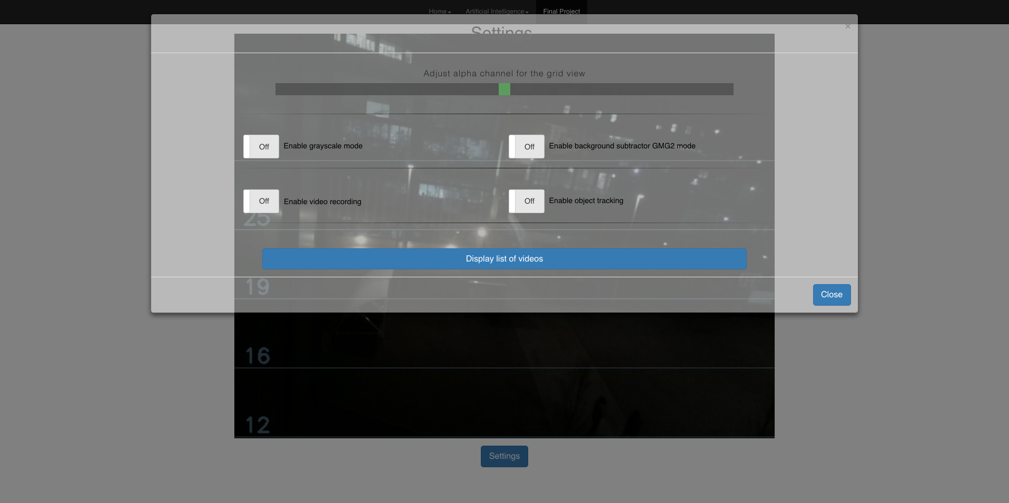

Figure 2 Web interface, settings view

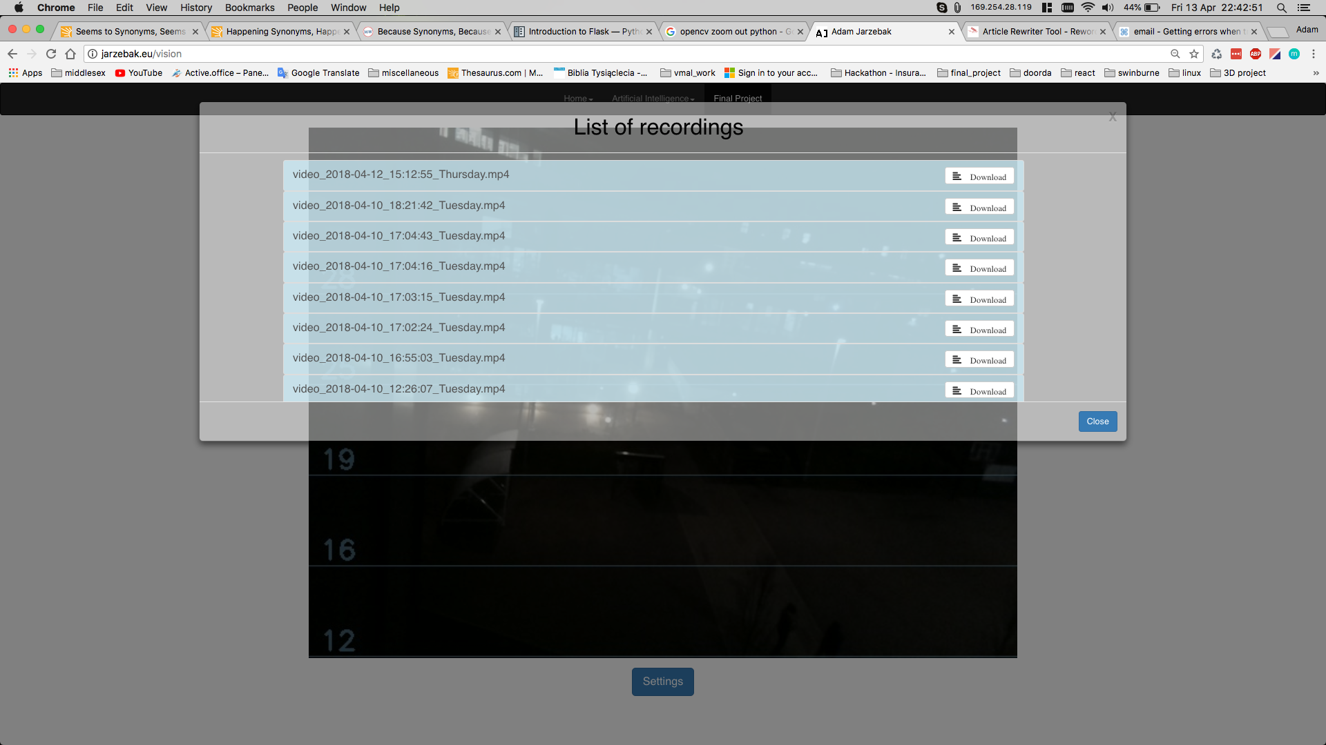

Figure 3 Web interface, files list display

## Finished Tasks

Notwithstanding the limitations of the methodology used which was specified in the project proposal, it was an important study in the development of how a system would potentially work and arrive at certain conclusion as well as finding another solution to presented problems. In light of the work achieved so far, I would like to present some example of labour put into this project.

The most significant part of this scheme is: successfully recognize an object from a give stream of video. There already exist and are available detection models. OpenCV supports a few kinds of detectors, including these two:

* Haar cascade - relatively reliable

(Detects light-to-dark edges, corners, and lines at multiple scales)

* Local binary pattern (LBP) – relatively fast

(Detects light-to-dark gradients at multiple scales)

Either of option requires to do some preparation, before attempting training.

This includes:

1. Negative training images
2. Positive training images
3. Create training data files
4. Create samples

Preparation itself is already very time-consuming process. In order to train good enough object detector, we are looking for around 2000 of negative images and about similar number for positives. Negative images can be collected arbitrarily from various websites. Another alternative is finding a source that contains packages of these images, which are already prepared for this process. Nevertheless, some extra work is required before using them.

Negative images are also called background images, and these terms are used interchangeably.

They can contain anything that we can only image, apart from the seeking object(s). Therefore, is required to go thought directory and make sure it does not contain an object we are looking for to detect in our program. Whereas for positive images, it is a little bit easier. One image is needed which contains an object we are looking for. In order to produce 2000 samples of positive images, we can use built-in functions in OpenCV library. This tool takes one image and using negative images, composes given number of samples. It is done by changing size, scale and rotating an object then imposes this object on positive image. At the same time, it produces an ‘info’ file. An info file stores information about location of freshly placed objects onto negative images.

* opencv_createsamples -img superCar.png -bg bg.txt -info samples/info.lst -pngoutput info -maxxangle 0.5 -maxyangle -0.5 -maxzangle 0.5 -num 1938

Using info file given out by previous command we can make ‘vec’ file. “Opencv_createsamples is used to prepare a training dataset of positive and test samples. opencv_createsamples produces dataset of positive samples in a format that is supported by both opencv_haartraining and opencv_traincascade applications. The output is a file with *.vec extension, it is a binary format which contains images.”

* opencv_createsamples -info info/info.lst -num 1938 -w 48 -h 24 -vec carsData.vec

The last stage of this process is running the cascade training command. Below command uses haar cascade training. It takes a long time to train, but are definitely more accurate. You can train a Haar cascade using the following command.

* opencv_traincascade -data data -vec cars.vec -bg bg.txt -numStages 10 -nsplits 2 -minhitrate 0.995 -maxfalsealarm 0.5 -numPos 1800 -numNeg 1800 -w 48 -h 24

There are more alternatives, yet these will do. The fundamental ones here are the quantities of positive and negatives. General consensus is that for most practices, you need to have 2:1 proportion of positive vs negative pictures. A few circumstances may vary; however, this is a general lead individual appear to take after. Next, we have stages. I picked 10. Normally is need 10-20 in any event here, the more, the more it will take, and it is again exponential.

This process is very time and resources consuming, on machine with 8GB RAM took about 12 hours for 10 stages.

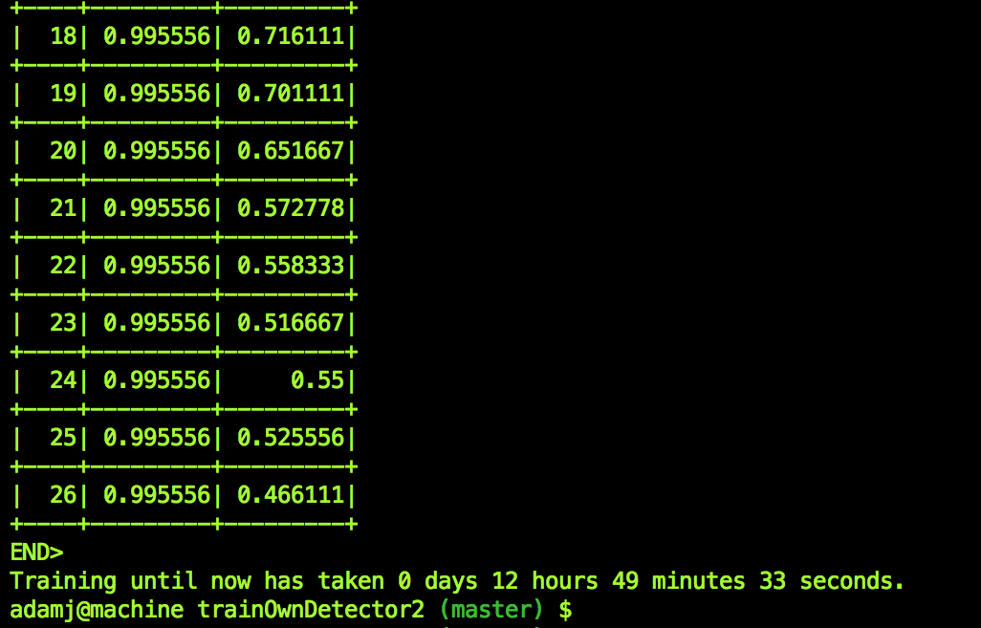

Figure 4 Sample output after a training command

These are only example of work that has been done. There is vast more details behind entire process of training an own detector. At this stage this seems to be challenging tasks, since achieving good results is not an easy task. So far detector is able to detect certain object but without too much accuracy. Analysis done on these attempts let me conclude that there needs to be higher number of samples. And perhaps better adjustment for parameters.

# Evaluation

Software is not dissimilar to other physical procedures where inputs are provided and returning an output. Although programming contrasts in results of failure. In case of failure for most physical devices it will be predicted, or it will happen in small range of ways. However, when considering this project where device will be flying and interacting in some sense with people, it is very important to reduce or totally eliminate any failure. In case of failure system will need to be prepared to handle this event. By differentiate, programming can fail in numerous strange ways. Therefore, for both software and hardware, it is very critical to perform multiple *formative evaluations.*

One of the goals during evaluation will be to examine what is a margin of admissible error. It needs to consider a difficulty of measuring a correct result from unstructured dataset, consisting of crowds and unknown background properties for images or video, as well as natural conditions.

Add data about how many people recongized successfully,

The following elements will be considering during this evaluation:

Usability

* Navigation
* Error checking
* Correctness according to requirements
* Ease of installation
* System requirements

Pedagogic aspects of the project

* Potential role
* Clearly stated objectives
* Assessment and feedback
* Challenge and motivation

As a method of evaluation for this project, the checklist seems to be most suitable. In this scenario, at the stage of writing a software, a project developer will need to write a system requirement for each of the units. For every unit, it will be required to perform a testing as well as conform whether software is following requirements. At the final stage, evaluation report needs to be written in a clear and consistent way. This report will also need to conform with a *summative evaluation*

# 

## Challenges Encountered

Installing software such as OpenCV can be already challenging tasks. It requires deeper understanding of Linux based OS. Moreover, installing all dependencies not necessary is smooth as should be. Hence, debugging skills are required, as well as broad knowledge about C++ compilators would be very useful. I already installed OpenCV on two machines, one is Mac laptop, and another is RaspberryPi. Currently working on full installation for OrangePi. Other challenges were related to training own detector. Where choosing parameters rarely were sufficient in order to successfully run a trainer. Various different factors are depending on this process. Such as, preparation itself is very important. More accoutre the preparation is it is more probable that training will succeed.

## Future Development

In the future I would like to work more on accuracy for classifier. Requirements are respectively high. Saying that would like to point out difficulty of detection any object from various backgrounds. For reference please see figure 3 attached.

Keeping in mind my research about thermal camera. Still requires from me to do more reading and research as well as studies on how to process this type of images. Finally, if time allows, I would like to make prototype of GUI implementation.

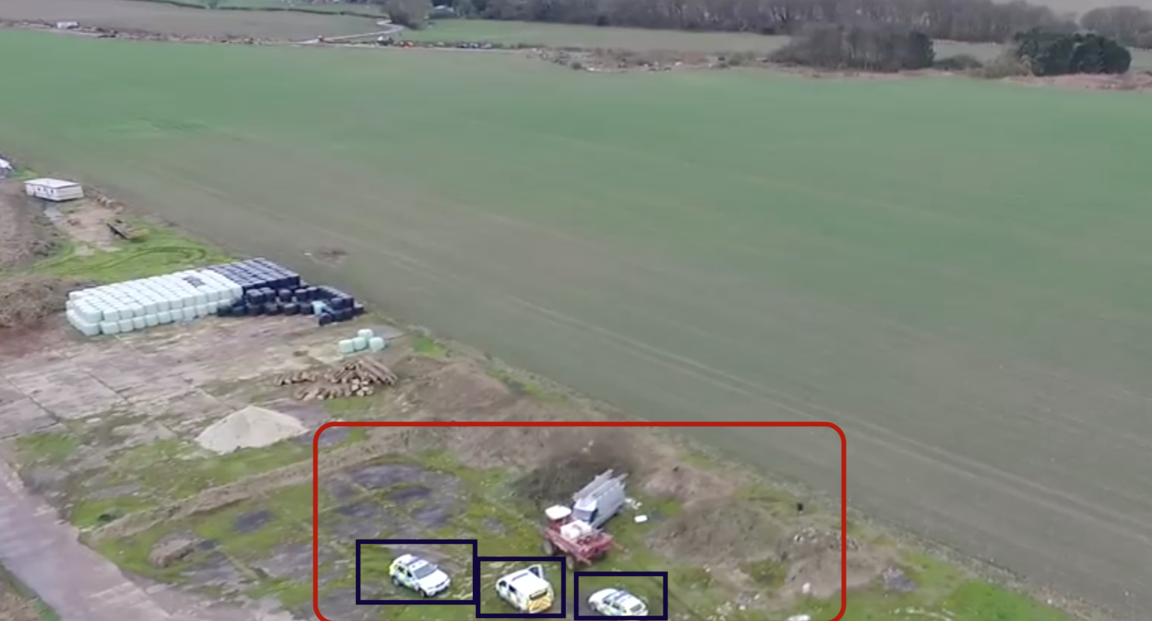

Figure 5 Sample scenario of detected objects

# Milestones

# List of references:

Barba-Guamán, L., Calderon-Cordova C., Quezada-Sarmiento P. (2017) ‘Detection of moving objects through color thresholding’, IEEE, 10.23919/CISTI.2017.7975755, Portugal.

Department for Environment Food & Rural Affairs, (2017) ‘Fly-tipping statistics for England, 2016/17’ Available from:

<https://www.gov.uk/government/uploads/system/uploads/attachment_data/file/652958/Flytipping_201617_statistical_release_FINAL.pdf >

[Accessed 13 January 2018]

Guennouni S., Ahaitouf A., Mansouri A. (2015) ‘Multiple object detection using OpenCV on an embedded platform’, *IEEE*, 10.1109/CIST.2014.7016649, Morocco.

Hossain N., Tanzir Kabir M., Rahman T., Hossen M., Salauddin F. (2015) ‘A Real-time Surveillance Mini-rover Based on OpenCV-Python-JAVA Using Raspberry Pi 2’, *IEEE*, 10.1109/ICCSCE.2015.7482232, Malaysia.

Howse J. (2014) ‘Training detectors and recognizers in python and OpenCV’, *ISMAR*, Proc. of ECCV

Leira F., Johansen T. (2015) ‘Automatic detection, classification and tracking of objects in the ocean surface from UAVs using a thermal camera’, *IEEE*, 10.1109/AERO.2015.7119238, USA.

Manlises C., Martinez J., Belenzo J., Perez C., Khristina M., Postrero T. (2015) ‘Real-Time Integrated CCTV Using Face and Pedestrian Detection Image Processing Algorithm For Automatic Traffic Light Transitions’, *IEEE*, 10.1109/HNICEM.2015.7393205, Philippines.

**To sort**

Begga R., Kamruzzamanb J. (2004) ‘A machine learning approach for automated recognition of movement patterns using basic, kinetic and kinematic gait data’, *Journal of Biomechanics*, 38, pp: 401–408, Elsevier - Melbourne.

Bradski, G. and Kaehler, A. (2008) *Learning OpenCV: Computer Vision with the OpenCV Library.* Gravenstein Highway North: O'Reilly Media.

Davies A., Velastin S., (2005) ‘A Progress review of intelligent CCTV Surveillance Systems’, *IEEE Workshop on Intelligent Data Acquisition and Advanced Computing Systems: Technology and Applications*, 0-7803-9446-1/05, Sofia*.*

Lee H., Choi J., Jeon E., Kim Y., Le T., Shin K., Lee H., Park K. (2015) ‘Robust Pedestrian Detection by Combining Visible and Thermal Infrared Cameras’, *MDPI - Sensors*, DOI:10.3390/s150510580.

Leykin A., Hammoud R. (2008) ‘Pedestrian tracking by fusion of thermal-visible surveillance videos’, *Machine Vision and Application,* DOI: 10.1007/s00138-008-0176-5.

Lima J., Farias T., Apolinário E., Moura G., Silva D., Teichrieb V., Kelner J. (2007) ‘Real-time pattern recognition using the opencv library’, *Symposium on virtual and augmented reality,* Hilton Charlotte Center City.

Macnish K. (2012) ‘Unblinking eyes: the ethics of automating surveillance’, *Ethics Inf Technol,* 14:151–16, DOI 10.1007/s10676-012-9291-0.

Mehran R., Oyama A., Shah M. (2009) ‘Abnormal Crowd Behaviour Detection using Social Force Model’, *IEEE*, 978-1-4244-3991-1/09, Florida.

Rodriguez M., Sivic J., Laptev I., Audibert J. (2011) ‘Data-driven Crowd Analysis in Videos’, *International Conference on Computer Vision,* Imagine, LIGM, UniversiteParis-Est.

Sjarif N., Shamsuddin S., Hashim S., Yuhaniz S., (2014) ‘Crowd Analysis and Its Applications’, *Soft Computing Research Group*, Universiti Teknologi Malaysia, Skudai, Johor.